

2026 SEMESTER 1 – Assignment 1

Course : Diploma in Electronics, Computer & Engineering

Module : EGE321 – Wireless Communications and Networking

May 2026

INSTRUCTIONS

- This paper contains 2 sections:
  - Section A: 3 Questions
  - Section B: 2 Questions
- Answer all questions.
- Show clear workings, labelled diagrams, and proper units.
- You may perform handwritten calculations where necessary.
- Graphs and diagrams may be produced using suitable software or drawn neatly by hand and attached to your assignment submission.

SECTION A - ANSWER ALL QUESTIONS ( 40 Marks )

Question 1

- With the aid of diagram, name and draw the three types of radio transmission modes in wireless communication. Explain how it works and give an example of each.
( 10 marks )

Question 2

- A communication link operates at a symbol rate of 50 ksymbols/s within a bandwidth of 100 kHz using 6 bits per symbol.

Compute the following:
- The data rate.
( 3 marks )

- The bandwidth efficiency of the radio link.
( 3 marks )

- Quality of Service (QoS) ensures that wireless communication networks meet user expectations. Discuss three critical QoS parameters that influence system performance, and explain how poor values in each could affect real-time applications such as video streaming or online gaming.
( 3 marks )

- With the aid of the frequency-time diagrams, explain how the following multiple access schemes can be implemented.
i) 3 users using FDMA.
ii) 9 users using a combination of FDMA ( 3 frequencies ) and TDMA

( 6 marks )

Question 3

The Figure below shows a typical setup of a RF transmitter consisting of the transmitter, a cable with a loss of 2dB, power amplifier of 10 dB and an antenna with a gain of 6dB.

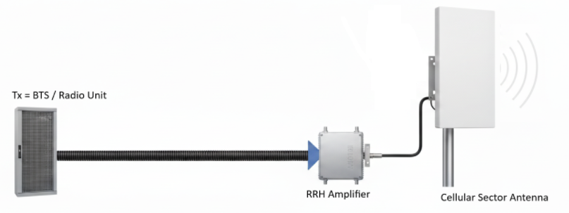
P_{T} = ?W
L_{f} = 2 dB
G_{T} = 6 dB
G = 10 dB

- Sketch on the figure the position where EIRP is referring to.
( 2 mark )

- Calculate the required output transmit power to achieve EIRP of 50dBm.
( 4 marks )

- A school IT technician is checking Wi-Fi coverage around the campus after upgrading the access points (APs). The technician notices the following situations:
  - Observation A: In a classroom on the ground floor, the Wi-Fi signal is weak but still usable from an AP across the hallway, even when the classroom door is closed and the AP cannot be seen directly.
  - Observation B: In the cafeteria, which has many metal tables and a big glass wall, students say the Wi-Fi signal keeps changing — sometimes strong, sometimes dropping — when they move only a few steps.
  - Observation C: During heavy rain, the outdoor Wi-Fi hotspot (used in the courtyard) becomes almost unusable, with very poor signal quality.

For each observation (A, B, and C), identify one specific radio wave propagation phenomenon that best explains what is happening, and briefly explains how this phenomenon affects the Wi-Fi signal in that situation.
( 9 marks )

SECTION B - ANSWER ALL QUESTIONS ( 60 Marks )

Question 4

The equation below represents the Free Space Propagation Model. From this equation, we can conclude that path loss depends on both frequency and distance. When substituting values into the equation, note that frequency must be expressed in megahertz (MHz) and distance must be in kilometers (km).

L_{P} = 32.4 + 20 log f (MHz) + 20 log d (km)

a) Complete the following table by calculating the path loss ($L_{P}$) for each frequency using the formula. Keep the distance fixed at 3 km.
( 10 marks )

Distance (km) | Frequency (MHz) | L_{P} = 32.4 + 20 log f (MHz) + 20 log d (km)
3 | 200
3 | 400
3 | 600
3 | 800
3 | 1000
3 | 1200
3 | 1400
3 | 1600
3 | 1800
3 | 2000

b) Plot a graph of Path Loss (dB) on the Y-axis against Frequency (MHz) on the X-axis. Label your axes clearly and use an appropriate scale.

( 14 marks )

c) From the graph, describe the relationship between frequency and path loss, and briefly explain why this trend occurs.
( 6 marks )

Question 5

Consider a particular base station in a cellular system operating in a large city with the following parameters:

Frequency of operation: 950 MHz
Base transmitter output power, P_{t}: P_{T} ( to be determined )
Mobile receiver sensitivity, P_{r}: -118 dBm
Base transmitter antenna gain, G_{t}: 4 dB
Mobile receiver antenna gain, G_{r}: 3 dB
Height of base transmitter, h_{te}: 60 m
Height of mobile receiver, h_{re}: 2 m
Distance, D: 4 km

Assuming all other losses are negligible except path loss and Rayleigh fading. Provision for fade margin for 99.8% reliability may be calculated with the help of the Rayleigh distribution chart provided (Treat the Fade Margin as additional loss along the path)

Rayleigh Distribution Chart:

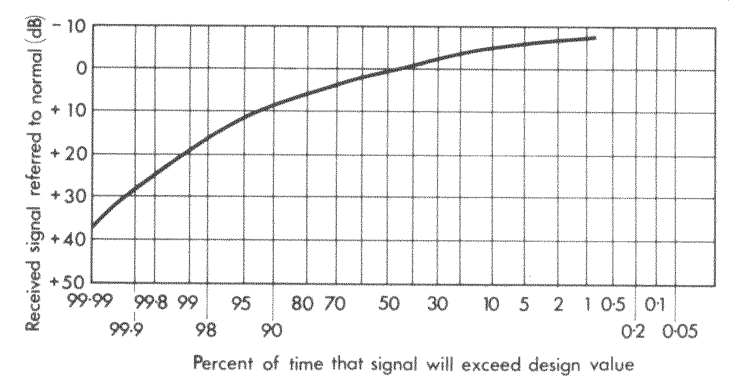

a) Draw a simple labelled diagram showing the base station–mobile link, indicating key components and gains/losses.
( 4 marks )

b) Write down the system equation.
( 4 marks )

c) Given that a cell radius of 4 km is required, calculate the path loss.
( 8 marks )

d) Determine the required power of the transmitter, P_{T} with 99.8% of communication link.
( 8 marks )

e) If the actual transmitter power available is 40 dBm, determine whether the link can still achieve the required receiver sensitivity.
Justify your answer by computing the resulting received power and comparing it to $P_{R}$.
( 6 marks )

